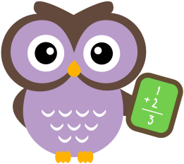
Monthly Family Math Checklist
Once the task is completed, please have your child complete the checklist by coloring a happy face or sad face to reflect on their work.
I understood the task
I solved the problem
I showed my work
I explained my answer

Teacher Comments:

